Diagnostic Analysis

Definition
# Source: AI Source: Provided by: [Data Path: Persons Table -> ID Column: 1, Name_En Column: Motasem Essam] -> From: [Chatgpt (GPT‑5 Mini)] on [12/10/2025]
Diagnostic analysis is the process of examining data to understand why something happened.
- It goes beyond descriptive analysis to identify causes, patterns, and relationships in the data.

Key idea:
# Source: AI Source: Provided by: [Data Path: Persons Table -> ID Column: 1, Name_En Column: Motasem Essam] -> From: [Chatgpt (GPT‑5 Mini)] on [12/10/2025]
It’s like investigating the reason behind a trend or event instead of just reporting the numbers.

Characteristics of Diagnostic Analysis
# Source: AI Source: Provided by: [Data Path: Persons Table -> ID Column: 1, Name_En Column: Motasem Essam] -> From: [Chatgpt (GPT‑5 Mini)] on [12/10/2025]
- Explains causes and relationships in historical data
- Uses drill-down techniques, correlations, and comparisons
- Often relies on visualizations, pivot tables, and statistical methods
- Helps in problem-solving and identifying root causes
- Requires detailed and accurate data

Example
# Source: AI Source: Provided by: [Data Path: Persons Table -> ID Column: 1, Name_En Column: Motasem Essam] -> From: [Chatgpt (GPT‑5 Mini)] on [12/10/2025]
A student database:
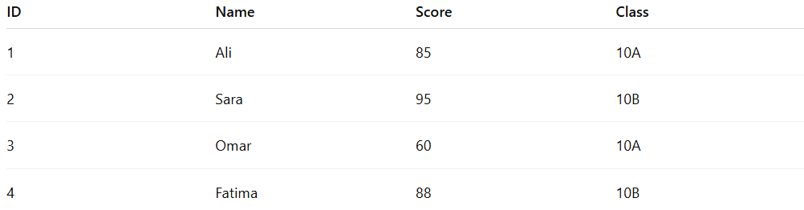
ID | Name | Score | Class
1 | Ali | 85 | 10A
2 | Sara | 95 | 10B
3 | Omar | 60 | 10A
4 | Fatima | 88 | 10B
Diagnostic Analysis Task: Why did Omar score lower than other students in Class 10A?
- Check attendance records, assignment completion, and participation
- Observation: Omar missed 4 classes and submitted 1 assignment late
- Conclusion: Low attendance and missing assignments contributed to the low score

Example Section
# Source: AI Source: Provided by: [Data Path: Persons Table -> ID Column: 1, Name_En Column: Motasem Essam] -> From: [Chatgpt (GPT‑5 Mini)] on [12/10/2025]
A teacher wants to understand why a student performed poorly:
Student | Score | Cause of Low Performance
Omar | 60 | Low attendance and missing assignment
- Diagnostic analysis explains the reason behind the result
- Helps the teacher plan interventions or remedial actions

Advantages
# Source: AI Source: Provided by: [Data Path: Persons Table -> ID Column: 1, Name_En Column: Motasem Essam] -> From: [Chatgpt (GPT‑5 Mini)] on [12/10/2025]
- Identifies causes behind trends or anomalies
- Supports problem-solving and decision-making
- Helps in improving processes or performance
- Provides insights beyond just numbers

Disadvantages
# Source: AI Source: Provided by: [Data Path: Persons Table -> ID Column: 1, Name_En Column: Motasem Essam] -> From: [Chatgpt (GPT‑5 Mini)] on [12/10/2025]
- Requires detailed and high-quality data; missing or inaccurate data can lead to wrong conclusions
- Can be time-consuming and complex to perform
- May involve subjective interpretation of patterns or correlations
- Not predictive—cannot tell what will happen in the future
- Relies on correct identification of relevant factors; overlooking key variables can mislead analysis

